Title: COSC363 Assignment 1

Student name: Zhi You Tan

Student number: 23021295 / zyt10

# Summary

Figure 1: Four happy robots.

The title of my assignment is Robot World. The settings in this project is by a mineral rich lakeside. In the scene, there are 4 robots living peacefully. One is a mining bot, one is a robot dog, one is a replica of the infamous BB-8 from Star Wars franchise and lastly a carefree robot who jumps up and down every day!

# Functions / Special key

There are a few buttons which can be pressed to interact with the program environment.

* Spacebar: To toggle between “free-view camera” and “first person view” from the jumping robot.

Navigation keys for “free-view camera” are:

* Up arrow key: To move “free-view camera” forward.
* Down arrow key: To move “free-view camera” backward.
* Left arrow key: To move “free-view camera” to the left by 5 degrees.
* Right arrow key: To move “free-view camera” to the right by 5 degrees.

# Features and its description

## Minimum Requirements

* All the robots in this project has some form of movement. For example, the robot dog can “walk” with four legs animation, BB-8 can move by gliding across the map while it’s lower body ball will spin, mining bot is able to walk to one of the ore and complete its action before moving to another ore to repeat the process and jumping robot is able to displace vertically.
* The most complicated task performed by a robot in this program is by the mining bot. The robot is capable of knowing whether it is in a “moving” phase or a “mining” phase. During moving phase, the robot will hold the pickaxe in a more comfortable position and walk with hands and leg animation; during mining phase, mining bot will lift the pickaxe high up and swing it down fast. The definition of mining is one swing in this program, therefore, the mining bot will head towards the other ore location right after each swing.
* There are two light sources in this program. One is used for shadow, while the other (spotlight) is used as a headlamp by the mining bot.
* Both ores (gold and silver) and BB-8 has GL_MODULATE set as its texture property. Thus, it has the capability to handle specular reflections. The more obvious case is when the mining bot shines its headlamp on the ores directly.
* Textures are used in this program to make the scene looks nicer. Textures used are BB-8 body and head, gold ore and silver ore.

## Extra Features

* 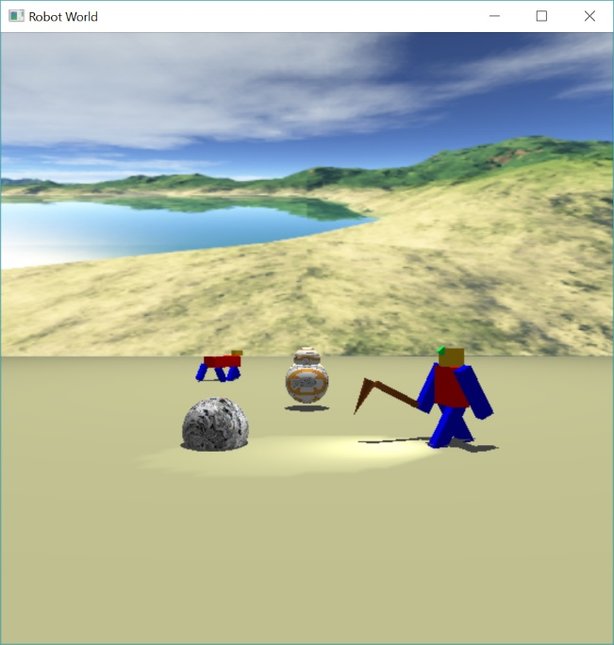Shadows are casts over all the robots and ores from a light source from (0, 200, 0).

Figure 2: First person view from jumping robot.

* A spotlight is created and attached to mining bot as a headlamp. The headlamp is attached and will move based on the displacement of the mining bot.
* Two camera modes can be toggled using ‘spacebar’. When in the free-view, user can navigate using up, down, left, right arrow key. When in the first-person view, user can see from the perspective from the jumping robot.
* A skybox is used to make the scene more realistic. The only exception is the bottom skybox. The reason is because I need to use smaller pixels for the floor to get light and shadow drawn.

# Challenges faced

One of the few challenges faced was with to make the mining robot pace back and forth. The problem was to maintain the state for walking and mining and switch when the state is done. Rotating the whole body was confusing at first, but it wasn’t that hard.

Another problem was the first-person view. First person view is also very confusing at first because of the look point. At first I was using the same value for the camera position and look point, the screen turns out black. The solution I used to solve this issue is by change the z look point different from the z camera position.

# References

Parts of the codes are from the lab.